MSD-54
Soft Dome Midrange
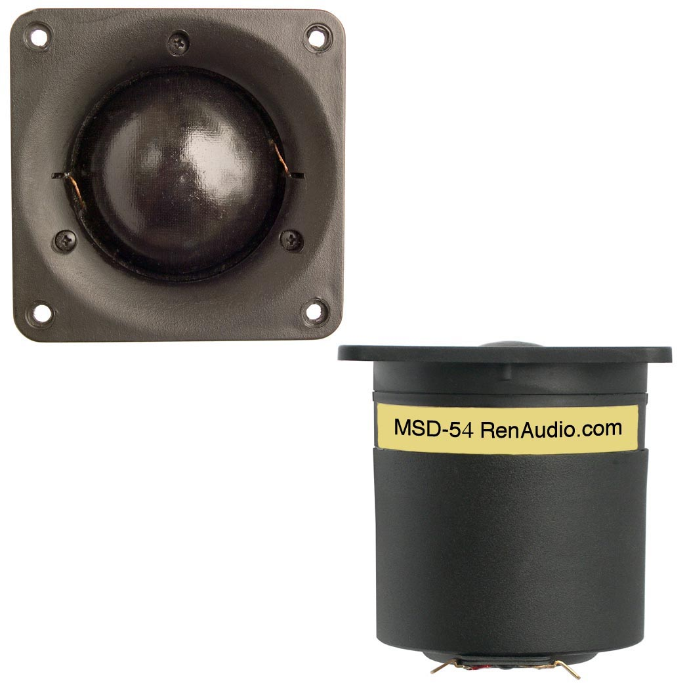
SPECIFICATIONS
Nominal Power Handling (RMS) |  | P | 200 W
Transient Power - 10 ms |  |  | 1,000 W
Nominal Impedance |  | Z | 8 Ω
Sensitivity 1W/1M |  |  | 90.5 dB
Frequency Response |  |  | 500 – 6,500 Hz
Resonant Frequency |  | FS | 380 Hz
VOICE COIL
Voice Coil Diameter |  | φ | 54 mm (2.1”)
Voice Coil Height |  |  | 6.0 mm (0.23”)
Voice Coil Former |  |  | aluminum
Voice Coil Wire |  |  | hexagonal shaped aluminum
Number of Layers |  |  | 2
DC Resistance |  | RE | 6.3 Ω
Voice Coil Inductance @ 1 kHz |  | LBM | 0.19 mH
MAGNET SYSTEM
Magnet System Type |  |  | neodymium, vented
Magnetic Gap Height |  | HE | 4.0 mm (0.16”)
Flux Density |  | B | 0.90 T
BL Product |  | BXL | 5.2 NA
Max. Linear Excursion |  | X | ± 1 mm
OPERATIONAL PARAMETERS
Suspension Compliance |  | CMS | -
Mechanical Q Factor |  | QMS | -
Electrical Q Factor |  | QES | -
Total Q Factor |  | Q/T | -
Mechanical Resistance |  | RMS | -
Moving Mass |  | MMS | 2.2 g
Equivalent Cas Air Load |  | VAS | -
Cone / Dome Material |  |  | hand treated fabric
Effective Piston Area |  | S | 28.0 cm²
Dimensions | Faceplate Diameter  Faceplate Thickness  Cutout  Mounting Depth |  | 87mm (3.43”)  4.0mm (0.16”)  76mm (2.99”)  82mm (3.23”)
Net Weight |  |  | 0.30 kg (0.66 lbs)

