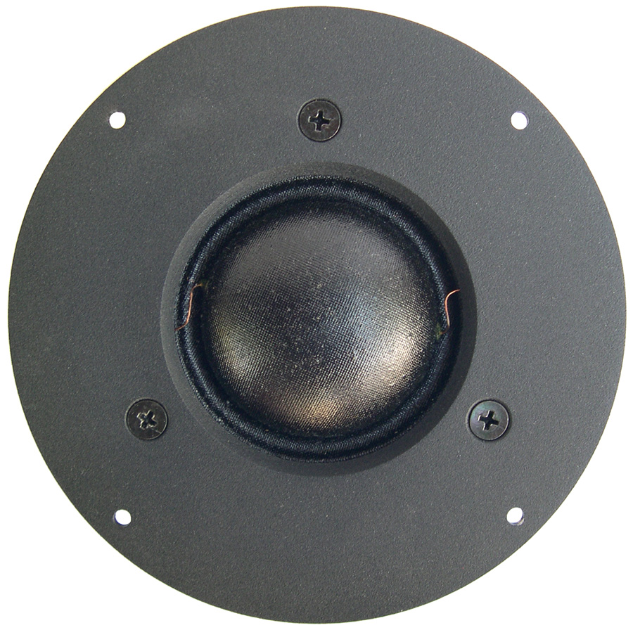
MSD-56
2.1” Soft Dome Midrange

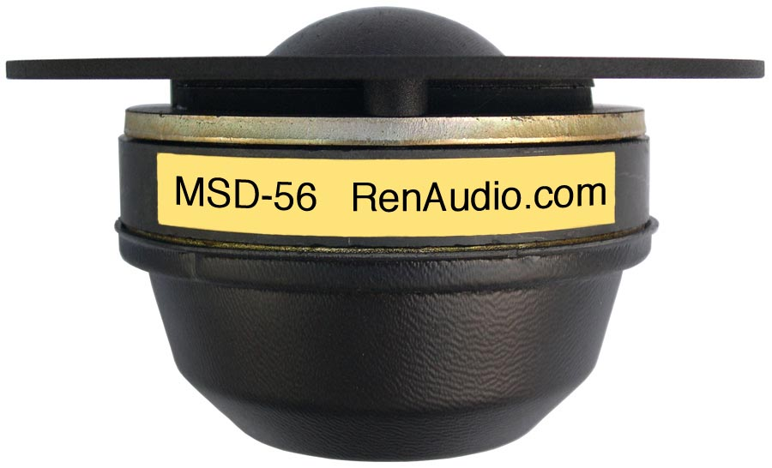

APPLICATION INFORMATION
Nominal Power Handling (RMS) |  | P | 200 W
Transient Power - 10 ms |  |  | 1,000 W
Nominal Impedance |  | Z | 8 Ω
Sensitivity 1W/1M |  |  | 90.5 dB
Frequency Response |  |  | 450 – 6,000 Hz
Resonant Frequency |  |  | 340 Hz
VOICE COIL
Voice Coil Diameter |  | φ | 55 mm (2.17”
Voice Coil Height |  |  | 7 mm (0.28")
Voice Coil Former |  |  | aluminum
Voice Coil Wire |  |  | hexagonal shaped aluminum
Number of Layers |  |  | 2
DC Resistance |  | RE | 5.2 Ω
Voice Coil Inductance @ 1 kHz |  | LBM | 0.19 mH
MAGNET SYSTEM
Magnet System Type |  |  | ferrite, chambered
BL Product |  | BXL | 6.4 NA
OPERATIONAL PARAMETERS
Mechanical Q Factor |  | QMS | 0.90
Electrical Q Factor |  | QES | 0.66
Total Q Factor |  | Q/T | 0.39
Moving Mass |  | MMS | 3.2 g
Cone / Dome Material |  |  | hand treated fabric
Effective Piston Area |  | S | 30.0 cm²
Dimensions | Faceplate Diameter  Faceplate Thickness  Cutout  Mounting Depth |  | 140mm (5.51””)  3.5mm (0.14”)  107mm (4.21”)  69mm (2.72”)
Net Weight |  |  | 1.3 kg (2.95 lbs)

