MSW-1115
4” Midrange

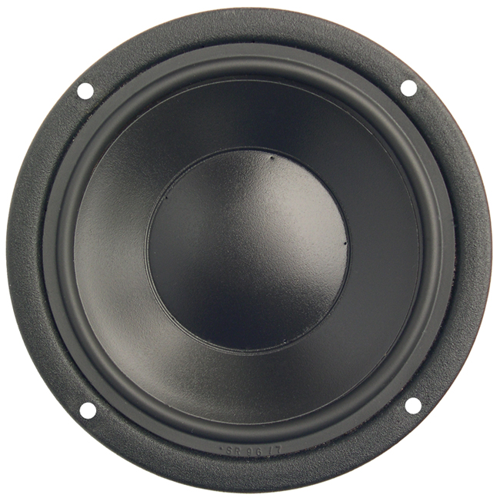

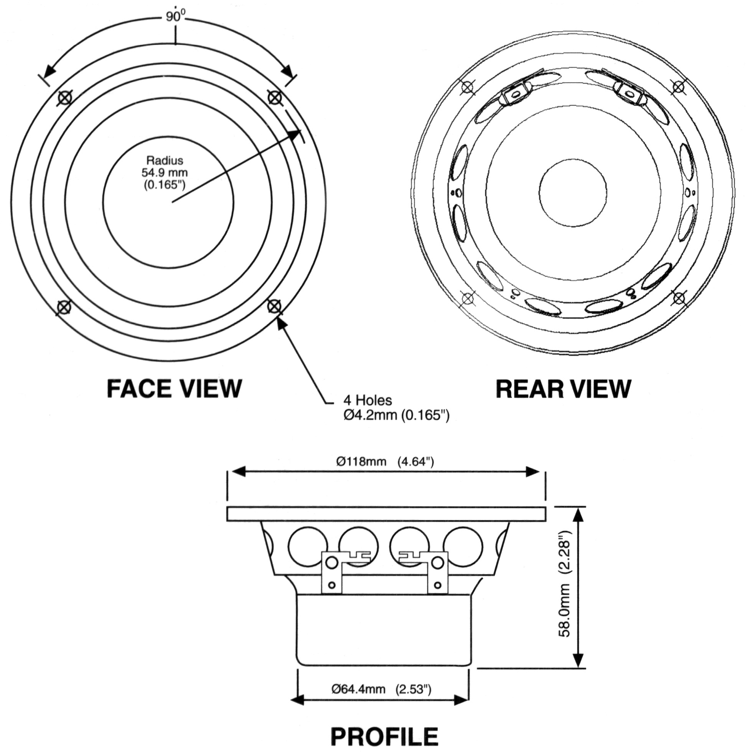

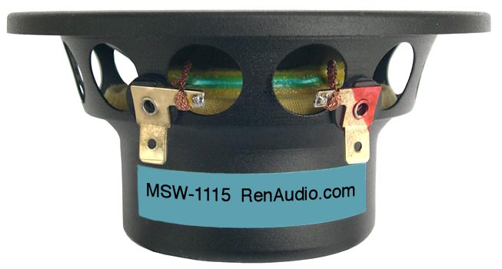

SPECIFICATIONS
Nominal Power Handling (RMS) |  | P | 120 W
Transient Power - 10 ms |  |  | 800 W
Nominal Impedance |  | Z | 8 Ω
Sensitivity 1W/1M |  |  | 87 dB
Frequency Response |  |  | 75 – 5,000 Hz
Resonant Frequency |  | FS | 78 Hz
VOICE COIL
Voice Coil Diameter |  | φ | 54mm (2.1”)
Voice Coil Height |  |  | 10.0 mm (0.39”)
Voice Coil Former |  |  | aluminum
Voice Coil Wire |  |  | hexagonal shaped aluminum
Number of Layers |  |  | 2
DC Resistance |  | RE | 5.6 Ω
Voice Coil Inductance @ 1 kHz |  | LBM | 0.42 mH
MAGNET SYSTEM
Magnet System Type |  |  | neodymium, vented
Magnetic Gap Height |  | HE | 6.0 mm (0.24”)
Flux Density |  | B | 0.88 T
BL Product |  | BXL | 7.06 NA
Max. Linear Excursion |  | X | ±2.0 mm (0.08”)
OPERATIONAL PARAMETERS
Suspension Compliance |  | CMS | 529 μM / newton
Mechanical Q Factor |  | QMS | 2.29
Electrical Q Factor |  | QES | 0.44
Total Q Factor |  | Q/T | 0.37
Mechanical Resistance |  | RMS | 1.347 Kg S⁻¹
Moving Mass |  | MMS | 6.30 g
Equivalent Cas Air Load |  | VAS | 2.76 L
Cone / Dome Material |  |  | damped polymer composite
Effective Piston Area |  | S | 61 cm²
Dimensions | Diameter  Cutout  Height  Mounting Depth |  | 118mm (4.65”)  98mm (3.86”)  58mm (2.28”)  54mm (2.13”)
Net Weight |  |  | 0.50 kg (1.1 lbs)

