MSW-10.5
10” Poly Cone Woofer

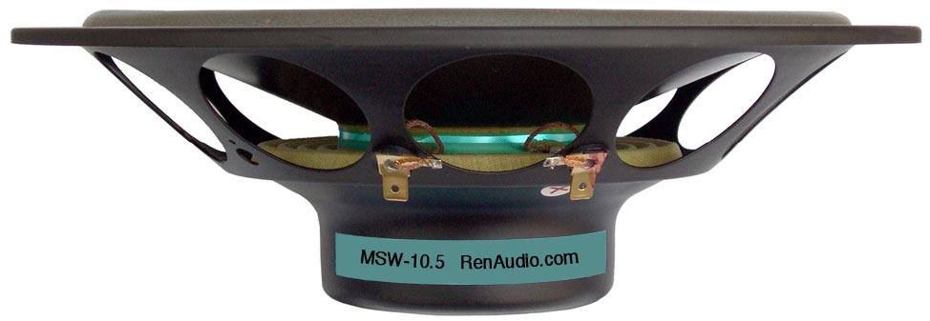

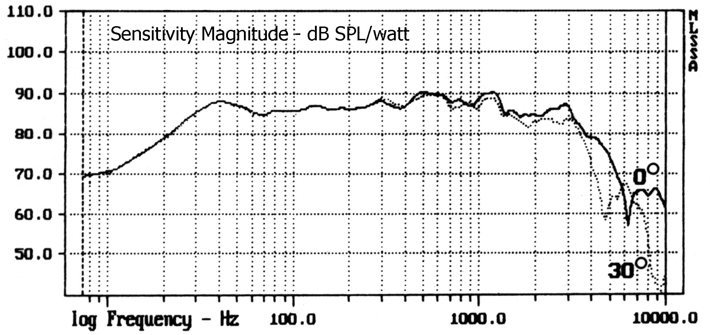

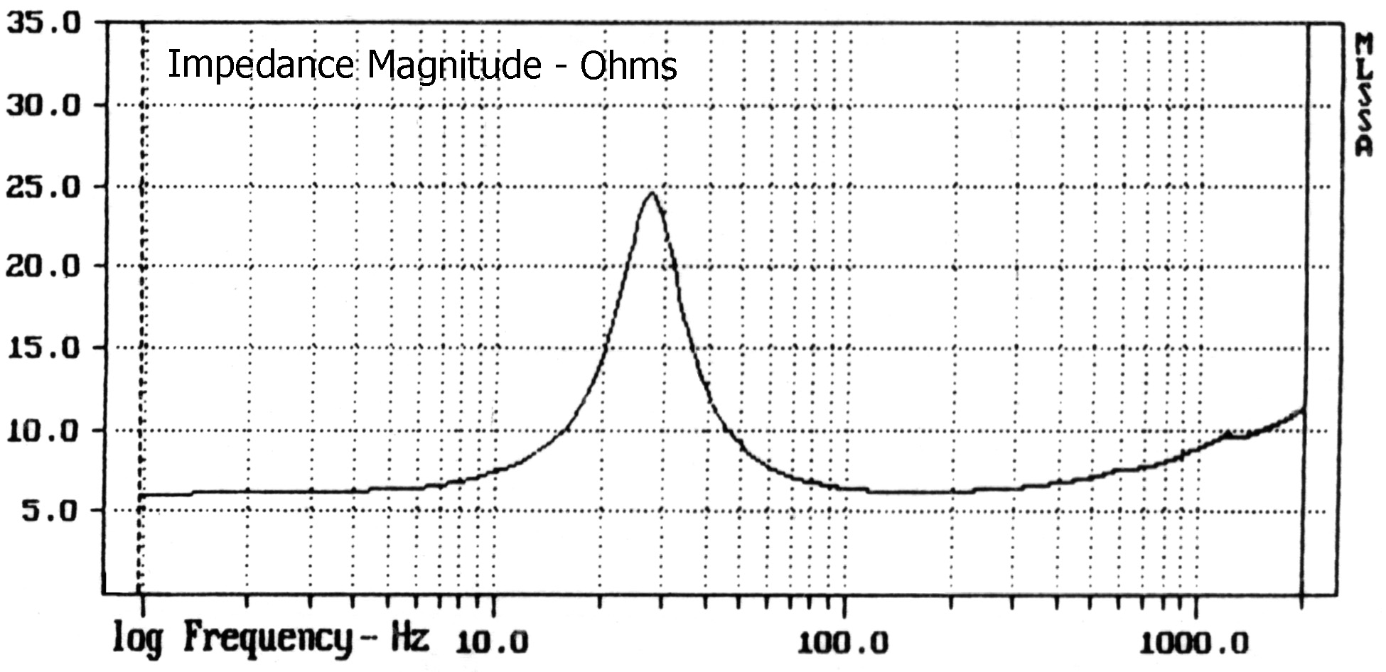

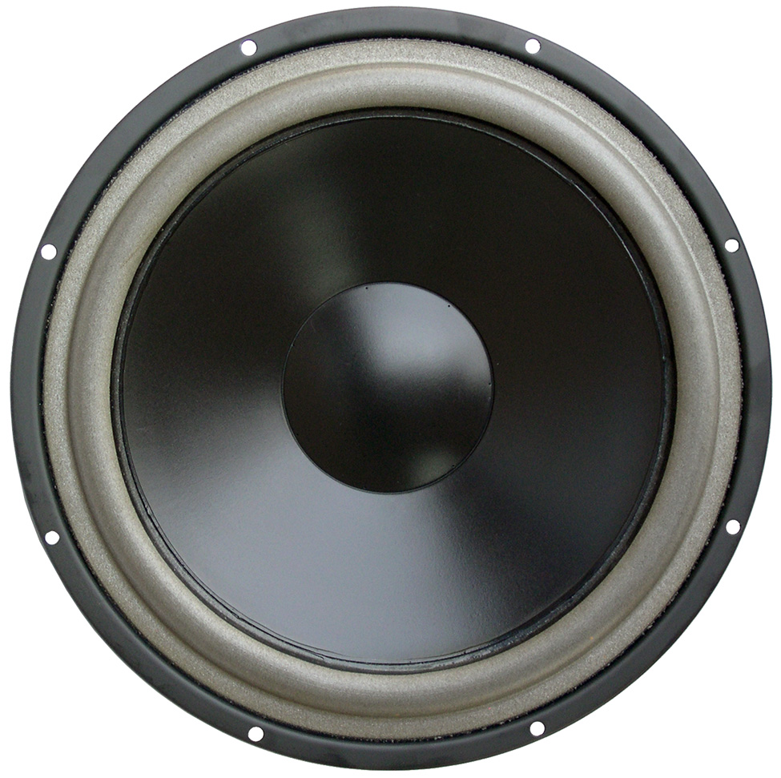

APPLICATION INFORMATION
Nominal Power Handling (RMS) |  | P | 180 W
Transient Power - 10 ms |  |  | 1,000 W
Nominal Impedance |  | Z | 8 Ω
Sensitivity 1W/1M |  |  | 89 dB
Frequency Response |  |  | 25 – 1,600 Hz
Resonant Frequency |  | FS | 29 Hz
VOICE COIL
Voice Coil Diameter |  | φ | 75mm (3”)
Voice Coil Height |  |  | 14.5 mm (0.57”)
Voice Coil Former |  |  | aluminum
Voice Coil Wire |  |  | hexagonal shaped aluminum
Number of Layers |  |  | 2
DC Resistance |  | RE | 6.3 Ω
Voice Coil Inductance @ 1 kHz |  | LBM | 0.63 mH
MAGNET SYSTEM
Magnet System Type |  |  | double ferrite, vented
Magnetic Gap Height |  | HE | 6.0 mm (0.24”)
Flux Density |  | B | 0.65 T
BL Product |  | BXL | 6.30 NA
Max. Linear Excursion |  | X | ±4.25mm (0.17”)
OPERATIONAL PARAMETERS
Suspension Compliance |  | CMS | 835 μM / newton
Mechanical Q Factor |  | QMS | 2.48
Electrical Q Factor |  | QES | 0.83
Total Q Factor |  | Q/T | 0.62
Mechanical Resistance |  | RMS | 2.393 Kg S⁻¹
Moving Mass |  | MMS | 32.6 g
Equivalent Cas Air Load |  | VAS | 123 L
Cone / Dome Material |  |  | damped polymer composite
Effective Piston Area |  | S | 324 cm²
Dimensions | Diameter  Cutout  Height  Mounting Depth |  | 263mm (10.35”)  229mm (9.02”)  80mm (3.15”)  75mm (2.96”)
Net Weight |  |  | 1.34 kg (2.9 lbs)

