MSW-1167
6” Poly Cone Midbass

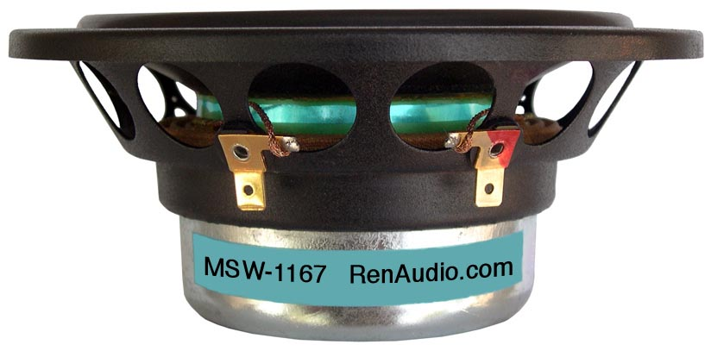
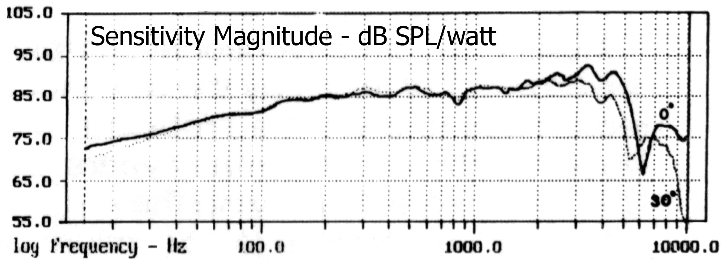

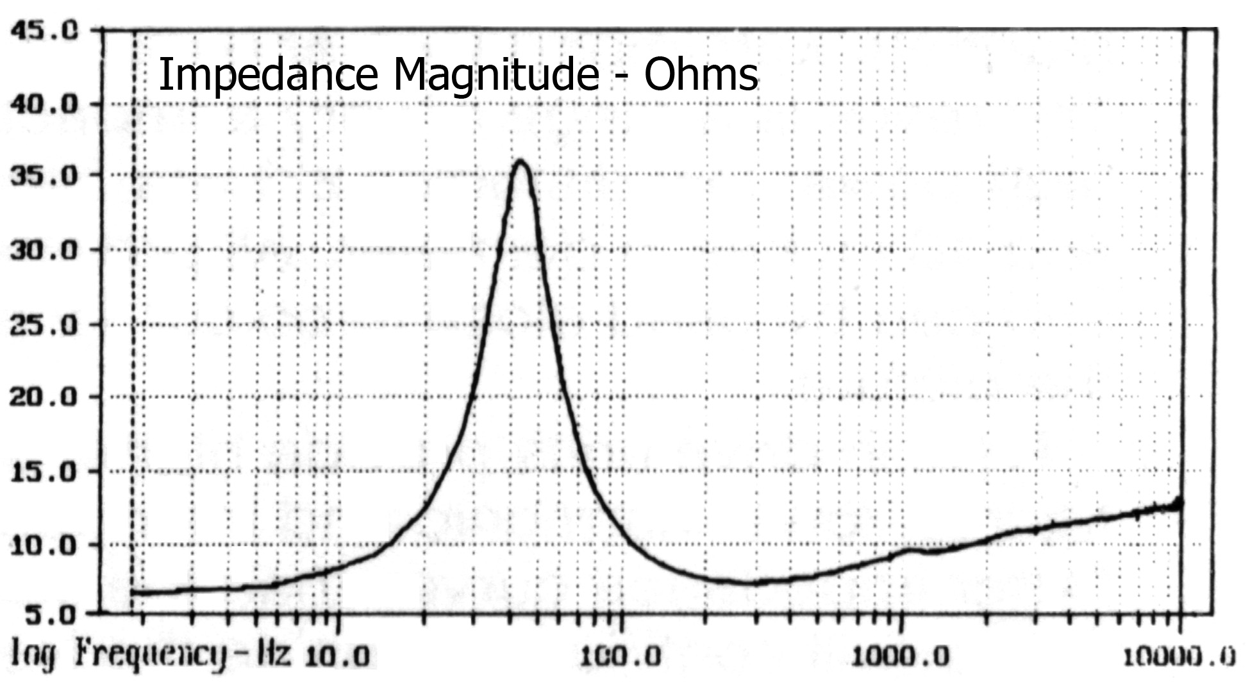

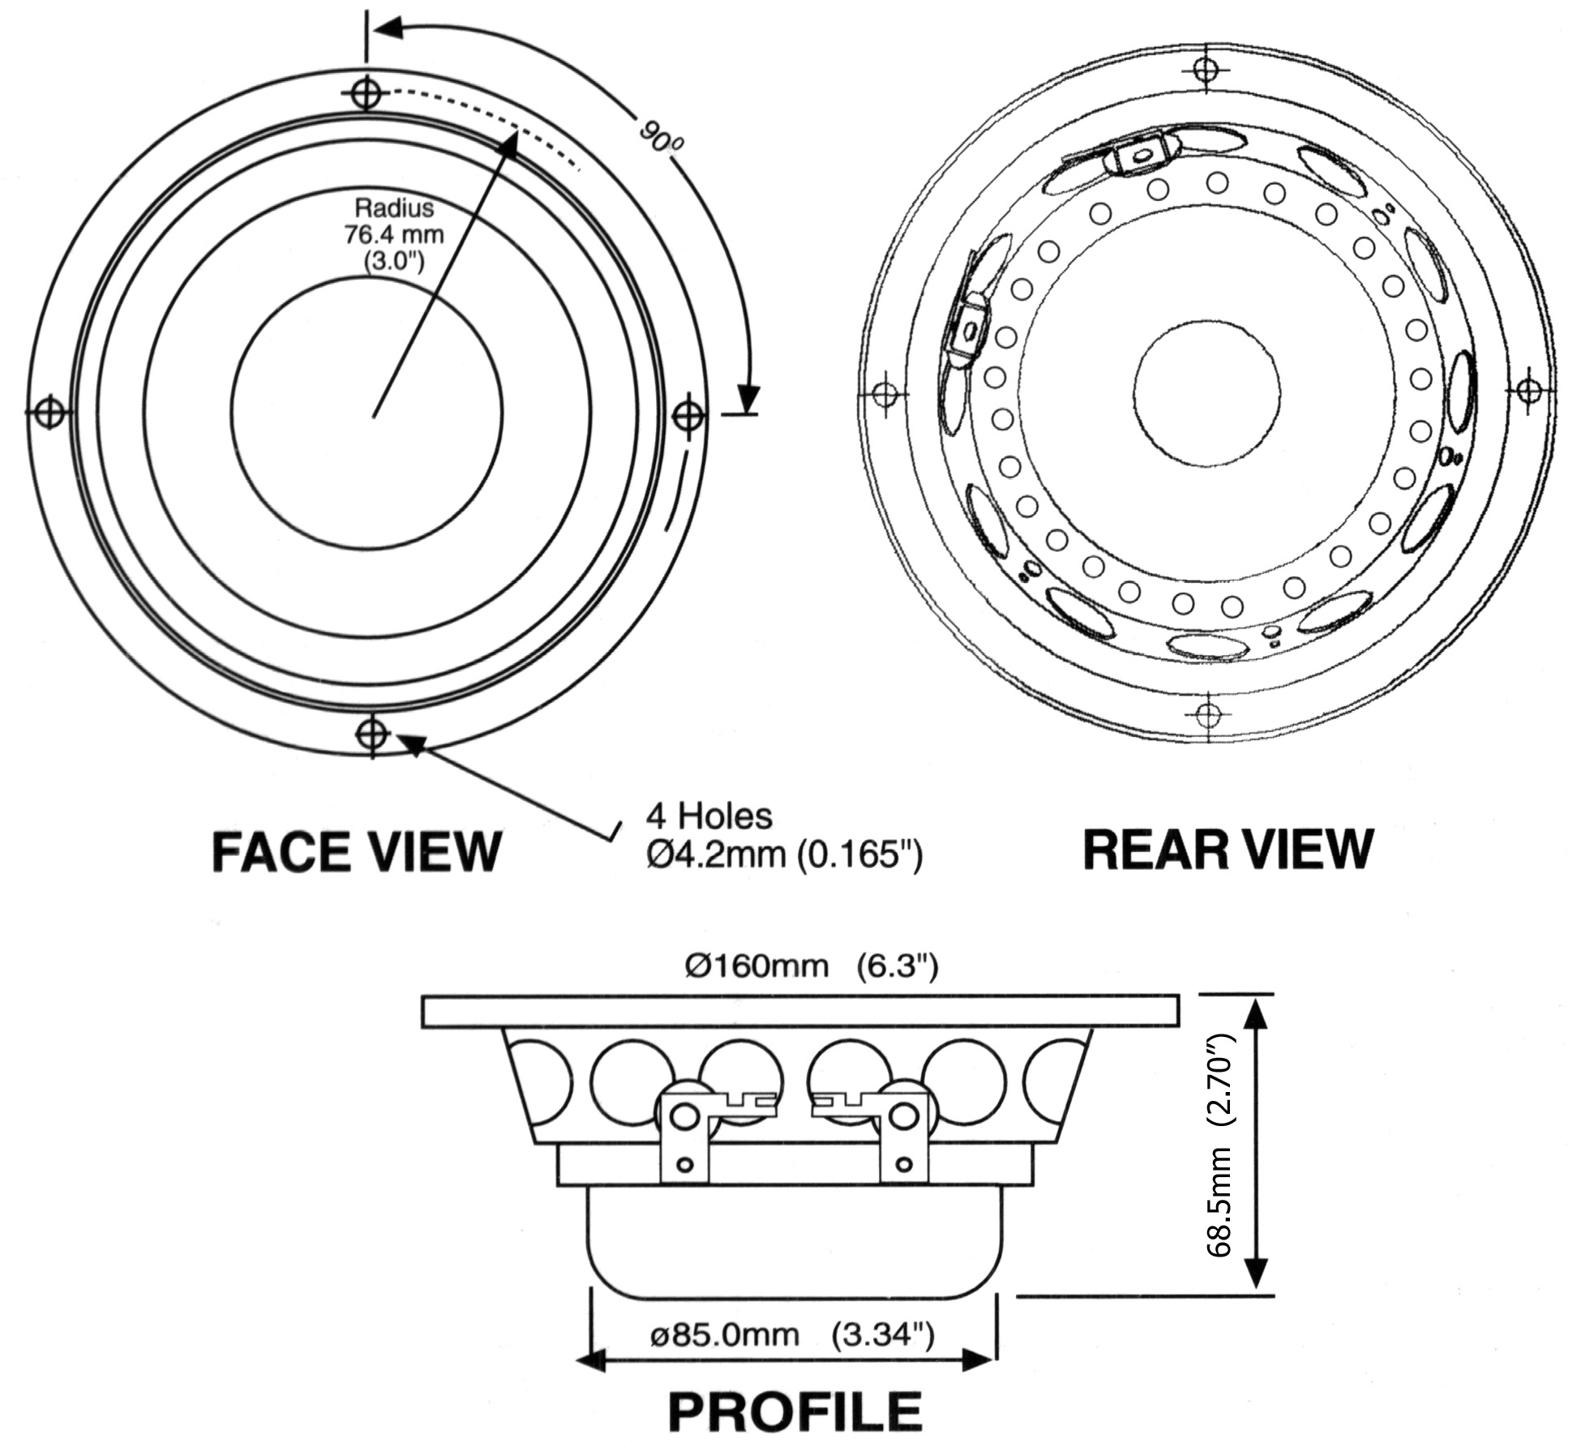

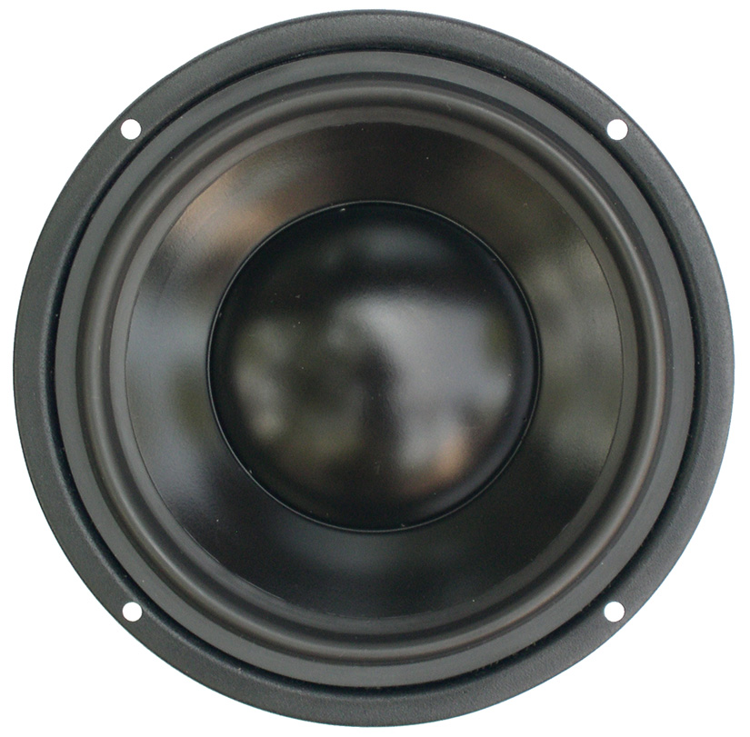

SPECIFICATIONS
Nominal Power Handling (RMS) |  | P | 150 W
Transient Power - 10 ms |  |  | 1,000 W
Nominal Impedance |  | Z | 8 Ω
Sensitivity 1W/1M |  |  | 88 dB
Frequency Response |  |  | 45 – 4,500 Hz
Resonant Frequency |  | FS | 44 Hz
VOICE COIL
Voice Coil Diameter |  | φ | 75mm (3”)
Voice Coil Height |  |  | 14.5 mm (0.57”)
Voice Coil Former |  |  | aluminum
Voice Coil Wire |  |  | hexagonal shaped aluminum
Number of Layers |  |  | 2
DC Resistance |  | RE | 6.6 Ω
Voice Coil Inductance @ 1 kHz |  | LBM | 0.08 mH
MAGNET SYSTEM
Magnet System Type |  |  | neodymium, vented
Magnetic Gap Height |  | HE | 6 mm (0.24”)
Magnetic Gap Width |  |  | 1.35mm (0.05”)
Flux Density |  | B | 0.82 T
BL Product |  | BXL | 7.80 NA
Max. Linear Excursion |  | X | ±4.25 mm (0.17”)
OPERATIONAL PARAMETERS
Suspension Compliance |  | CMS | 945 μM / newton
Mechanical Q Factor |  | QMS | 1.99
Electrical Q Factor |  | QES | 0.43
Total Q Factor |  | Q/T | 0.35
Moving Mass |  | MMS | 14 g
Equivalent Cas Air Load |  | VAS | 18.80 liters
Cone / Dome Material |  |  | damped polymer composite
Effective Piston Area |  | S | 119 cm²
Dimensions | Diameter  Cutout  Height  Mounting Depth |  | 160mm (6.30”)  134mm (5.28”)  68.5mm (2.70”)  62mm (2.44”)
Net Weight |  |  | 1.1 kg (2.4 lbs)

