MSW-12.1
12” High-Power Subwoofer

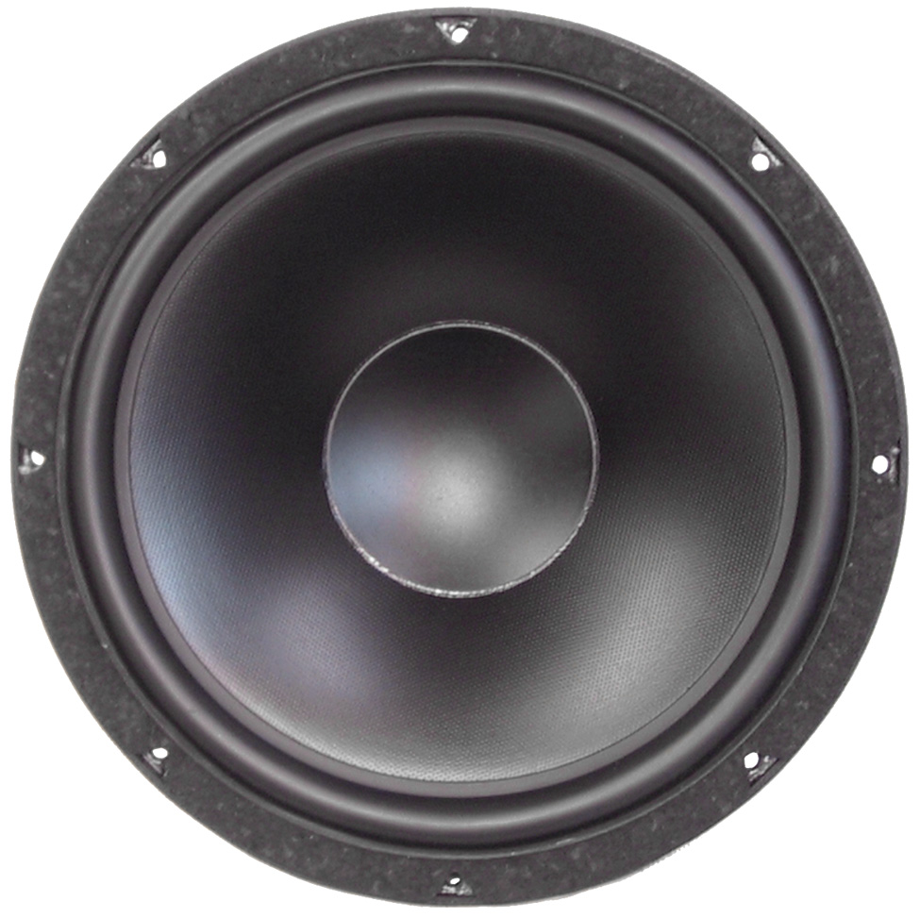

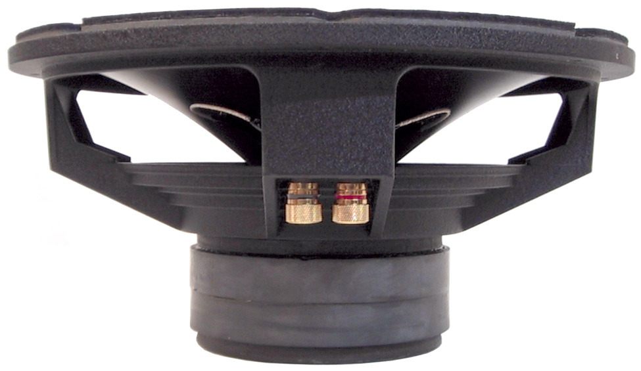

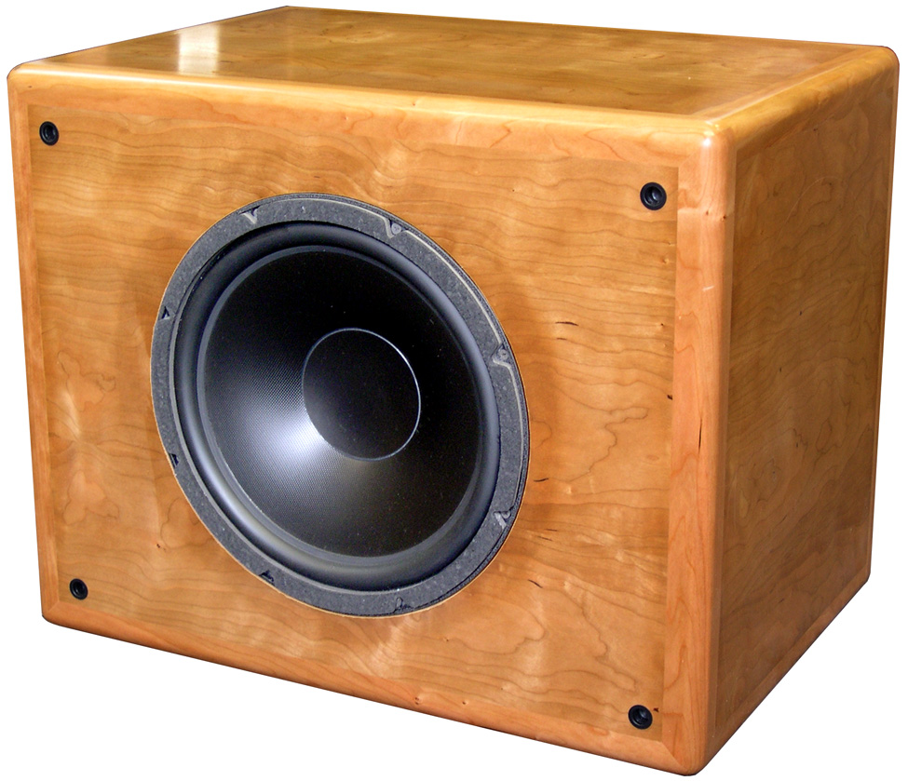

SPECIFICATIONS
Power Handling (RMS) |  | P | 400 W
Transient Power Handling |  |  | 1,500 watts
Sensitivity SPL @ 1watt |  | SPL₀ | 90.8 dB
Nominal Impedance |  |  | 8 Ω
Resonant Frequency |  | Fs | 23.3 Hz
VOICE COIL
Voice Coil Height |  |  | 30mm
DC Resistance |  | R_{evc} | 6.2 Ω
Zmax @ F₀ |  | Z₀ | 217.0 Ω
MAGNET SYSTEM
Flux x Length |  | BL | 21.6 TM
Maximum Linear Excursion |  | X_{max} | 10mm
Ref Efficiency |  | N₀ | 0.76 %
OPERATIONAL PARAMETERS
Compliance |  | C_{ms} | 377.3 μM/N
Mechanical Q Factor |  | Q_{ms} | 8.21
Electrical Q Factor |  | Q_{es} | 0.24
Total Q Factor |  | Q_{ts} | 0.23
Moving Mass |  | M_{ms} | 123.4 grams
Diaphragm Mass |  | M_{md} | 116.4 grams
Equivalent Cas Air Load |  | VAS | 150.5 Litres
Cone Material |  |  | polypropylene
Surround Material |  |  | santoprene™
Piston Area |  | S_{d} | 0.05 M²
Dimensions | Diameter  Cutout  Height  Mounting Depth |  | 315mm (12.4”)  283mm (11.1”)  156mm (6.1”)  140mm (5.5”)
Net Weight |  |  | 6.36 kg (14 lbs)

