MSW-1265
8” Poly Cone Woofer
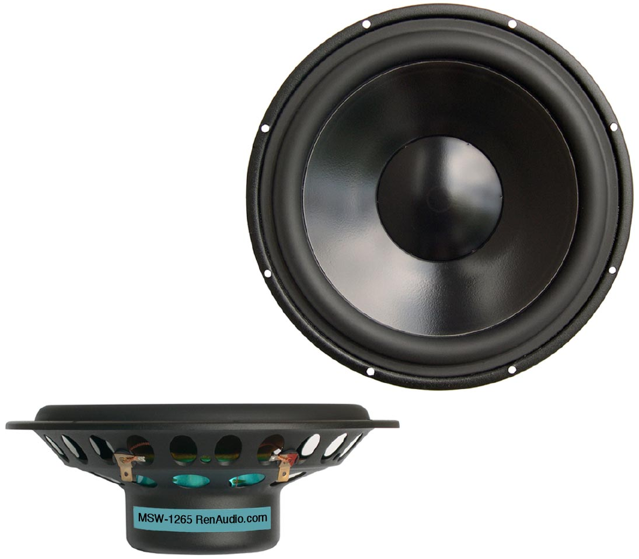

SPECIFICATIONS
Nominal Power Handling (RMS) |  | P | 150 W
Transient Power - 10 ms |  |  | 1,000 W
Nominal Impedance |  | Z | 8 Ω
Sensitivity 1W/1M |  |  | 90 dB
Frequency Response |  |  | 30 – 2,600 Hz
Resonant Frequency |  | FS | 30 Hz
VOICE COIL
Voice Coil Diameter |  | φ | 75mm (3”)
Voice Coil Height |  |  | 12 mm (0.47”)
Voice Coil Former |  |  | aluminum
Voice Coil Wire |  |  | hexagonal shaped aluminum
Number of Layers |  |  | 2
DC Resistance |  | RE | 5.2 Ω
Voice Coil Inductance @ 1 kHz |  | LBM | 0.58 mH
MAGNET SYSTEM
Magnet System Type |  |  | double ferrite, vented
Magnetic Gap Height |  | HE | 5.0 mm (0.20”)
Flux Density |  | B | 0.72 T
BL Product |  | BXL | 6.30 NA
Max. Linear Excursion |  | X | ±3.5 mm (0.14”)
OPERATIONAL PARAMETERS
Suspension Compliance |  | CMS | 1,316 μM / Newton
Mechanical Q Factor |  | QMS | 2.16
Electrical Q Factor |  | QES | 0.55
Total Q Factor |  | Q/T | 0.44
Mechanical Resistance |  | RMS | 2.006 Kg S⁻¹
Moving Mass |  | MMS | 23 g
Equivalent Cas Air Load |  | VAS | 88.6 L
Cone / Dome Material |  |  | damped polymer composite
Effective Piston Area |  | S | 219 cm²
Dimensions | Diameter  Cutout  Height  Mounting Depth |  | 222mm (8.74”)  196mm (7.72”)  73.5mm (2.89”)  69mm (2.72”)
Net Weight |  |  | 1.2 kg (2.63 lbs)
